**Design Of Composite Bridge**

Project-1 (CE57003) report submitted to

Indian Institute of Technology, Kharagpur

In partial fulfillment for the award of

Master of Technology (Hons)

In Civil (Structural) Engineering

by

**G.V.S.Sri Ram**

**(15CE31015)**

**Under the Supervision of**

**Prof. Nirjhar Dhang**

**Department of Civil Engineering**

**Indian Institute of Technology, Kharagpur**

**Autumn Semester, 2019-20**



**DECLARATION**

I certify that

1. The work contained in this report has been done by me under the guidance of my supervisor.
2. The work has not been submitted to any other Institute for any degree or diploma.
3. I have conformed to the norms and guidelines given in the Ethical Code of Conduct of the Institute.
4. Whenever I have used materials (data, theoretical analysis, figures, and text) from other sources, I have given due credit to them by citing them in the text of the thesis and giving their details in the references. Further, I have taken permission from the copyright owners of the sources, whenever necessary.

**Date**: 14-11-2019 G.V.S. Sri Ram

**Place**: Kharagpur (15CE31015)

**DEPARTMENT OF CIVIL ENGINEERING**

**INDIAN INSTITUTE OF TECHNOLOGY, KHARAGPUR**

**KHARAGPUR-721302, INDIA**

**CERTIFICATE**



This is to certify that the project report entitled “**Design of Composite Bridge**” submitted by **G.V.S. Sri Ram** **(15CE31015)** to Indian Institute of Technology, Kharagpur towards partial fulfillment of requirements for the award of degree of Masters of Technology in Civil Engineering is a record of bonafide work carried out by him under my supervision and guidance during Autumn Semester 2019-20.

Date: 14-11-2019 Prof. Nirjhar Dhang

Place: Kharagpur Department of Civil Engineering

Indian Institute of Technology Kharagpur

# 

# **ACKNOWLEDGMENT**

I would like to express my sincere gratitude and heartfelt thanks to my supervisor Prof.Nirjhar Dhang for his guidance and gracious support throughout my project work. It was a pleasure to work under his guidance. His valuable suggestions and co-operation throughout the session helped me to overcome the difficulties. It is due to his effort that the project work has been completed on time.

I am thankful to all faculty members, who were always approachable all the time for any help and suggestion throughout my entire course. I am thankful to the Civil Engineering Department, IIT Kharagpur for providing me all the facilities needed for the completion of my project.

.

**Date** : 17-10-2019 G.V.S.Sri Ram

**Place** : Kharagpur 15CE31015

## 

## **TABLE OF CONTENTS**

|  |  |  |
| --- | --- | --- |
| 1.0 | Introduction | 6 |
| 1.1 | Objective | 7 |
| 1.2 | Scope of work | 7 |
| 2.0 | Literature Survey | 8-10 |
| 3.0 | Theoretical Formulation | 12-14 |
| 4.0 | Design of Composite Bridge | 15-20 |
| 5.0 | Conclusions | 21 |
| 6.0 | Works to be carried out | 22 |
| 7.0 | References | 22-24 |

## **1.0.** **Introduction**

Bridges are important components of the transportation system. For in-service bridges, the reduction of resistance caused by the deterioration of materials and the increase of traffic intensity due to the economic growth has raised serious concerns over their safety.

Bridge condition assessment through structural health monitoring (SHM) can provide real-time information on the performance and health condition of bridges, allowing bridge owners to make well-informed decisions for bridge maintenance and management. In the past decades, numerous studies have been conducted on the condition assessment of bridges, and different assessment strategies were proposed (Aktan et al. 1997; Xia et al. 2008; Ni et al. 2012; Ma et al. 2014; Xia et al. 2017). A bridge can be considered safe if it has the capacity to withstand the expected loading during its design life. Therefore, in order to evaluate the safety condition of existing bridges during their remaining life, a statistic-based method is needed to predict the extreme traffic load effects (LEs) of bridges based on the monitoring data.

### 

### **1.1.** **Objective**

The main objective is to design steel girders for the various spans and model the composite bridge using these steel girders

### **1.2.** **Scope of work**

Part I

· Design of different steel girders for spans of 10,20,30, etc.

· Design plate girders for larger depths

Part II

· Model the bridge in Abaqus software by assigning suitable steel girder for suitable span using Python programming

# 

## 2.0. Literature survey

##### **Prediction of Extreme Traffic Load Effects of Bridges Using Bayesian Method and Application to Bridge Condition Assessment**

**Yang Yui**:

In this study, they had introduced the Bayesian method for the prediction of extreme traffic LEs of bridges to improve the reliability of the prediction. The detailed estimation procedures were presented. The Bayesian method provides a systematic framework of uncertainty quantifications for extreme value analysis. Compared with the conventional method, the Bayesian method can quantify the uncertainties of parameters in terms of posterior distributions and incorporate the uncertainties into the prediction through the posterior predictive distribution. The prediction results are intended for the application of bridge condition assessment for which a framework was proposed to evaluate the bridge condition at two different levels

##### **Characteristics of a bridge condition assessment method based on state representation methodology (SRM) and damage detection sensitivity**

**Akito Yabe:**

In this study, a new method for damage detection (performance evaluation) from a large amount of continually collected measurement data by applying the State Representation Methodology (SRM) was proposed, and a number of time-frequency analysis methods necessary for the implementation of the proposed method were compared and discussed. As part of the study, the SRM scale parameter, which can affect damage detection accuracy, was also evaluated experimentally

##### 

##### 

##### **Structural Health Monitoring of I-10 Twin Span Bridge – Part I: Analysis of Lateral Load Test**

**Murad Y. Abu-Farsakh:**

An SHM (structural health monitoring) system was successfully installed at the M19 eastbound pier of the new I-10 Twin Span Bridge over Lake Pontchartrain. The system consisted of instrumenting both the substructure and the superstructures of the bridge. The SHM system will be used for long-term health monitoring of the bridge during selected events such as storm surge, extreme wind, and vessel impact.

A high-order-polynomial curve fitting method was selected to best-fit the measured rotation profiles by IPI. From the fitted rotation profiles, bending moments, shear forces, and soil reactions were derived using the classical beam theory. P-y curves were obtained from the derived soil reaction profiles and deflection profiles. The back-calculation results were verified with the measurement data from IPI and strain gauges. FB-MultiPier was used for the analysis of pier behaviors in the design of the I-10 Bridge.

Therefore, it was selected to simulate the pier response during the lateral load test and verify its performance with measured data and results from the back-calculation. A sensitivity analysis of the input parameters for FB-MultiPier was first conducted to help make decisions on selecting design parameters. Based on the analysis of the simulation results, a select set of inputs was presented as a reference for the design of a similar battered pile group in the future.

##### **Learn the Abaqus script in one hour**

**J.T.B. Overvelde:**

This particular article deals with creating Abaqus script for modeling database and output database. It explains the syntax and command for each of the actions to be done in Abaqus software using Python.

This manual is not meant to be a complete Abaqus script manual. It is an introduction to Abaqus script from a practical viewpoint and it tries to explain an easy, fast way to start scripting. The manual tries to show the author’s viewpoint on the power and simplicity of scripting.

##### **Abaqus Scripting User’s Manual**

**Simulia:**

This document gives us full knowledge of Abaqus scripting. It was released by Simulia, the makers of Abaqus. The Abaqus Scripting Interface is an application programming interface (API) to the models and data used by Abaqus. The Abaqus Scripting Interface is an extension of the Python object-oriented programming language; Abaqus Scripting Interface scripts are Python scripts.

We can get a brief idea about the following:

* Create and modify the components of an Abaqus model, such as parts, materials, loads, and steps.
* Create, modify, and submit Abaqus analysis jobs.
* Read from and write to an Abaqus output database.
* View the results of an analysis

##### **Condition assessment and retrofit of a historic steel-truss railway bridge**

**Constantine C. Spyrakos:**

In this particular study, the analysis and design calculations for the new train types specified by the owner showed that the main truss system can carry the new loads, while strengthening is required only in the transverse secondary beams. A thorough inspection and in situ measurements showed that the original drawings have been accurately followed and are in full agreement with the existing geometry and dimensions of the bridge. The systematic and periodic inspection and maintenance are primarily attributed to the relatively good condition of the bridge.

A procedure to minimize interruption of traffic during strengthening works on the bridge must be developed since the transverse secondary beams that need strengthening are directly connected to the rail tracks. It concluded that the bridge can safely fulfill the design requirements and future needs of the GRO, provided that the suggested strengthening is materialized

##### 

##### Condition Assessment of Shear Connectors in Slab-Girder Bridges via Vibration Measurements

##### **Yong Xia, Hong Hao:**

##### The author has studied the condition assessment of shear connectors using two methods. The model updating approach indicated that the condition of the girders and bearings is good but that the entire slab has some degree of deterioration, and these findings were supported by visual observation. Using a new damage index method, which compares the response of the slab and girders, the condition of the shear connectors was also evaluated. Combining the results obtained by the two approaches, it was concluded that most of the shear connectors in the first two spans are in fair condition, but those in the third span are not good.

## 

## 3.0 Theoretical Formulation

### **The methodology adopted for the design of Plate Girders:**

There are two basic assumptions in this method.

Assumption-1: Bending moment will be resisted by the flanges

Assumption-2: Shear will be resisted by web

*For Fe410 grade of steel:*

fu = 410MPa

fy = fyp = fyw = 250 MPa

µ = 0.3

E = 2 × 105 MPa

Partial safety factors γmw = 1.50 (for site welding)

= 1.25 (for shop welding

𝞊 = 𝝴w = 𝞊f = √(250/fy)

Design of web When intermediate transverse stiffeners are not to be provided:

d/tw ≤ 200𝞊 from serviceability criteria

≤ 345𝞊f2 from flange buckling criteria

Assume suitable k = d/tw based on the above limiting criteria.

Optimum depth of plate girder,d = (Mzk/fy)0.33

Optimum web thickness,tw = (Mz/fyk2)0.33

Design of flanges: take γm0 = 1.1

Required area of the flange, Af = Mzγm0 /fyd

Assume width of flange equal to 0.3 times depth of girder

### **Methodology for analysis in Abaqus:**

We want to model the steel girder which can support our bridge.

So we find a total load of the bridge and distribute it across all the steel girders equally.

Pressure on steel girder due to the weight of concrete = (*d*A*g/n*a),

Where rho=density of concrete,

d=depth of the concrete part

A=area of bridge

g=acceleration due to gravity

n=number of steel girders

a=area of each steel girder

There will be the self-weight of steel acting on it and IRC class 70R load is being applied.

Pressure on top due to IRC class 70R loading is found in two situations.

*Case-1: Partial Load case*

In this case, we are considering the situation where one track is directly on top of the girder and another track is located at a distance away from it.

In this case, load from the track directly above is transferred 100% to the girder and load from another is partly transferred i.e , where a is the distance of the second track from girder and b is spacing between two girders.

*Case-2: Full Load case*

In this case, we are considering the situation where two tracks are on either side of the girder.

In this case, load from both of the tracks are transferred 100% to the girder and thus load acting is 0.5P+0.5P = P

### 

### **Methodology for creating Abaqus script using Python:**

The Abaqus Scripting Interface is an extension of the Python object-oriented programming language; Abaqus Scripting Interface scripts are Python scripts. You can use the Abaqus Scripting Interface to do the following:

* Create and modify the components of an Abaqus model, such as parts, materials, loads, and steps.
* Create, modify, and submit Abaqus analysis jobs.
* Read from and write to an Abaqus output database.
* View the results of an analysis.

Figure-1: Flow Chart representing Abaqus Kernel reading input data

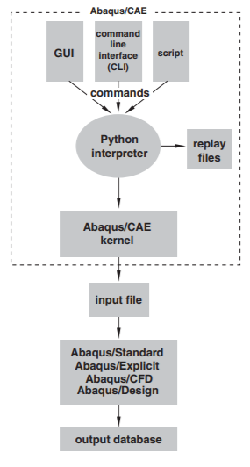

The above figure shows us the flowchart of the way Abaqus reads Python Scripts.

There is a specific command in Abaqus script by Python programming for each of the actions to be done in Abaqus. Each command is to be passed in a specific syntax (format) which will be decoded by Abaqus software later and creates our model.

## 4.0. Design of Composite Bridge

### **4.1 Design of Steel Girder**

The number of lanes and shoulders defines the width of the bridge.

The entire width of the concrete deck is supported by steel girders, concrete transfers load from vehicle to steel girders which in turn transfer them to piers.

Steel girders are placed at equal intervals along the width of the deck.

Figure-2: Three-span steel composite part of I-10 Twin Span Bridge, Lousiana

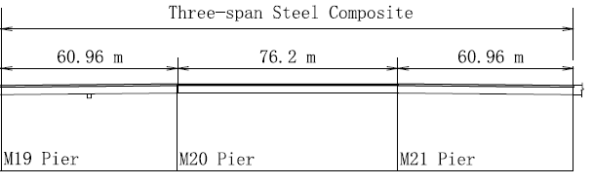

The above longitudinal view of the bridge is a part of I-10 Twin Span Bridge in Louisiana

Figure-2: Cross-sectional View of I-10 Twin Span Bridge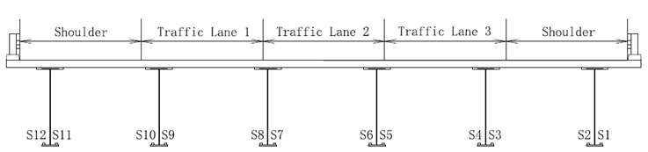

This cross-section has been considered for designing and modeling of the bridge. Considering the concrete portion, the depth is fixed as 250 mm.

Considering the width of each lane as 3.5m and shoulder as 1.2m, total width of deck = 3x3.5 + 2*1.2 = 12.9m

Considering the density of concrete = 2400 kg/m3

Pressure due to the weight of concrete on each girder per length of span = 2400x0.25x9.8/6 = 5880 Pa

The self-weight of steel is applied.

Considering IRC 70R loading, Partial vehicle load is load applied due to a single track and full load is due to two tracks.

Partial Vehicle load on girders = 350*1000/Area

Full Vehicle load on girders = 700*1000/Area

Area = width x span, varies as span varies. We design for spans of 10m, 20m, 30m, 40m, 50m, and 60m.

Table-1: Loads on steel plate girders

|  |  |  |
| --- | --- | --- |
| Span(m) | Partial Load (Pa) | Full Load (Pa) |
| 10 | 29717 | 37554 |
| 20 | 13798 | 21717 |
| 30 | 11159 | 16438 |
| 40 | 9839 | 13798 |
| 50 | 9047 | 12214 |
| 60 | 8519 | 11159 |

Applying the above pressure on top of girders, modeling and analyzing girder model in Abaqus software, we found out the maximum stress(considering tension and compression)

Considering I beam of depth=600mm, web thickness=12mm, flange thickness=20.8mm and width of flange=210mm, we find out partial vehicle load and full vehicle load on girders.

Our desired allowable maximum stress (both tension and compression) is 120Mpa. This is being satisfied only by span 10m. So, we design plate girders for other spans.

Here are the final design specifications of plate girders we could provide for different spans

Table-2: Design specifications of plate girders for different spans

|  |  |  |  |  |  |  |  |
| --- | --- | --- | --- | --- | --- | --- | --- |
| Span(m) | Partial Load Case (MPa) | Full Load Case (MPa) | Depth (mm) | tw (mm) | tf (mm) | b(mm) | Weight (Kg/m) |
| 10 | 59.6 | 74 | 600 | 12 | 20.8 | 210 | 120 |
| 20 | 85 | 115 | 1000 | 12 | 20 | 250 | 168 |
| 20 | 77.6 | 97.6 | 1000 | 16 | 30 | 250 | 234 |
| 30 | 83 | 102 | 1500 | 16 | 40 | 300 | 364 |
| 30 | 73.4 | 94.2 | 1500 | 20 | 36 | 300 | 390 |
| 40 | 75.7 | 87.3 | 2250 | 20 | 40 | 300 | 527 |
| 40 | 71.5 | 83.5 | 2250 | 25 | 40 | 300 | 610 |
| 50 | 88 | 99.7 | 2750 | 32 | 50 | 360 | 942 |
| 60 | 84.7 | 90 | 3500 | 40 | 60 | 400 | 1429 |
| 70 | 91.4 | 102 | 4000 | 55 | 75 | 450 | 2178 |
| 80 | 93 | 110 | 4500 | 70 | 100 | 500 | 3128 |

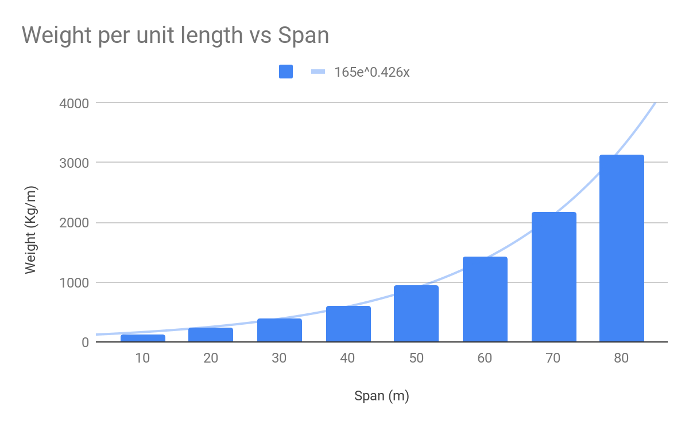

We can do an exponential interpolation if we want to find out the weights per unit length for a different span. This can be computed by

,

Where A0 = Weight at lower span than given length,

B0 = Weight at higher span than given length,

x=length of the span,

A = length of the lower span

We don't want to provide any stiffener here, so we are providing totally steel instead.

Here are the sample screenshots of the Abaqus models that are created (Table-1)

**Span-10m Full Load**

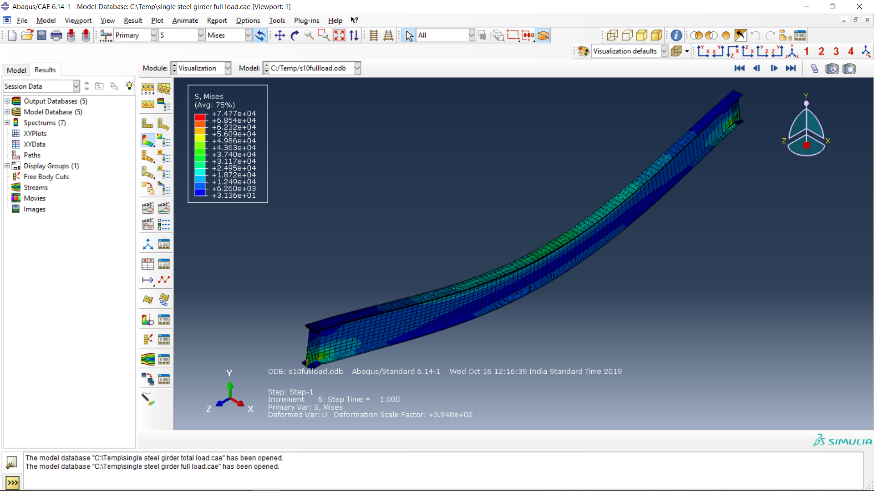

**Span-20m Full Load**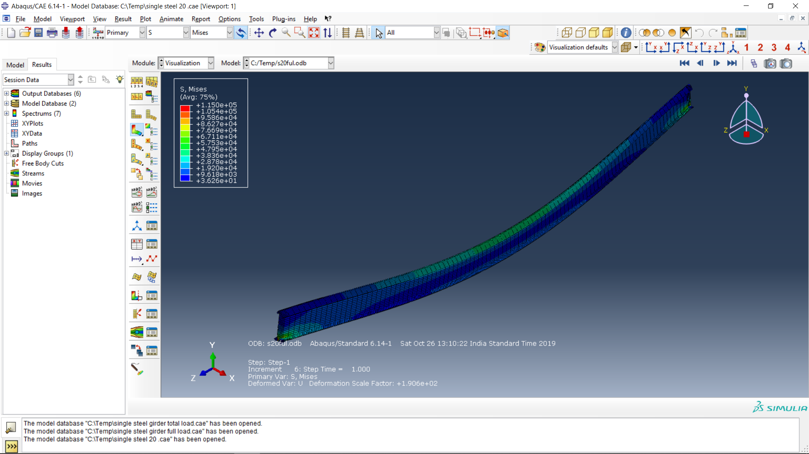

**Span-20 Partial Load**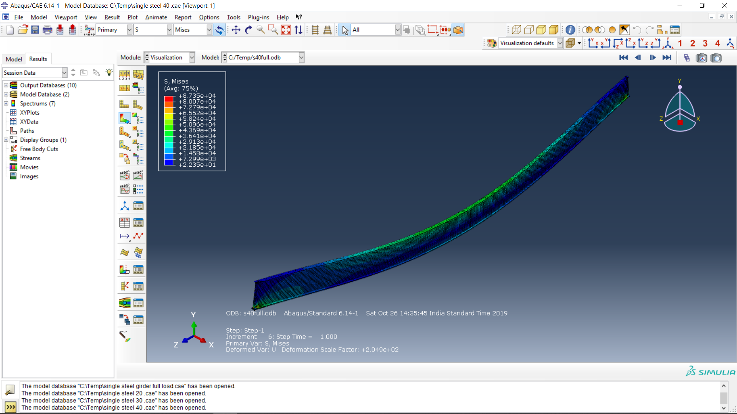

**Span 20 Modified Full Load**

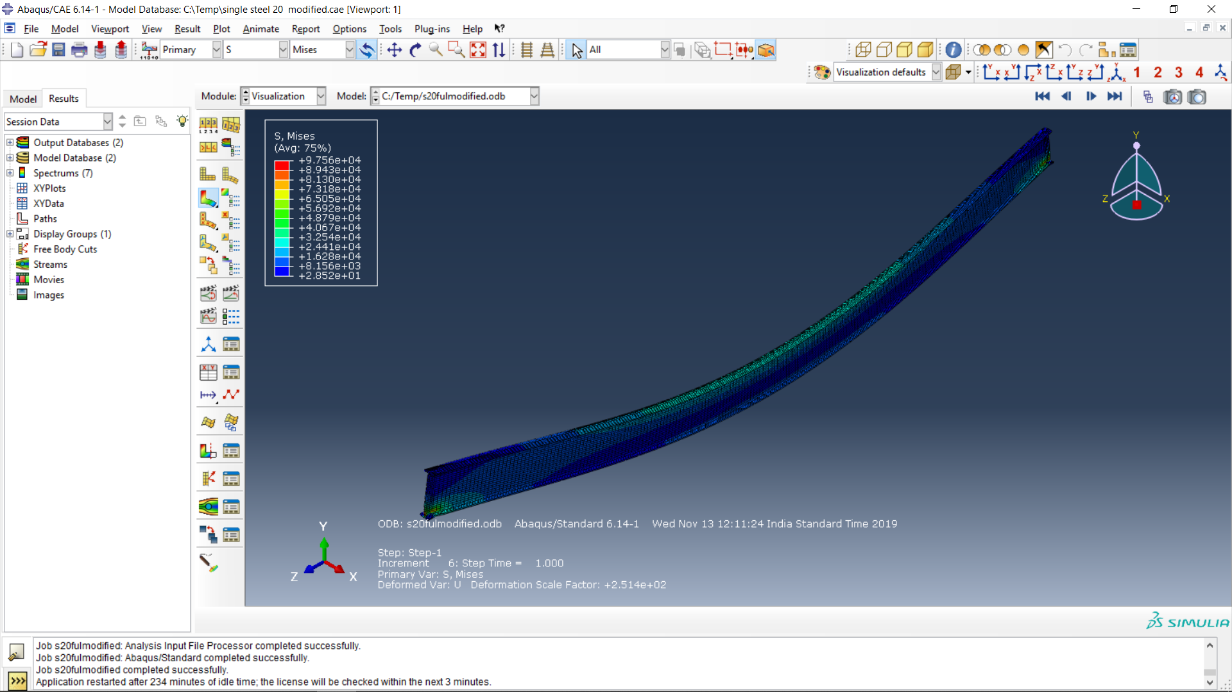

**5.0. Conclusions**

The design specifications of plate girders have been computed and finalized after carrying out analysis in Abaqus software.

For a particular span, we are choosing the plate girder of the higher span length we have designed. i.e, for a span of 25m we use plate girder designed for 30m span.

These plate girders will be used to design the real composite part of the bridge. These girders are placed at equal distances across the cross-section of the bridge and analysis should be carried out again to check if they are withstanding the traffic.

Our final bridge design should be modeled in Abaqus software using Python Programming i.e Abaqus Scripting Python.

## 

## **6.0. Works to be carried out**

In Part II of this project, the following work will be done

-Finish the model in Python Programming Language

-Our final bridge design should be modeled in Abaqus software using Python Programming i.e Abaqus Scripting Python.

## 

## 6.0 References

1. Yang Yu, S.M.ASCE and C. S. Cai, Ph.D., P.E., “Prediction of Extreme Traffic Load Effects of Bridges Using Bayesian Method and Application to Bridge Condition Assessment,” *Journal of Bridge Engineering*, ASCE, ISSN 1084-0702,

DOI: [10.1061/(ASCE)BE.1943-5592.0001357](https://ascelibrary.org/doi/abs/10.1061/%28ASCE%29BE.1943-5592.0001357)

2. Akito Yabe · Ayaho Miyamoto · Eugen Brühwiler, “Characteristics of a bridge condition assessment method based on state representation methodology (SRM) and damage detection sensitivity”, Journal of Civil Structural Health Monitoring (2019) 9:233–251

3. Aktan, A., D. N. Farhey, A. J. Helmicki, D. L. Brown, V. J. Hunt, S. K. Lee, and A. Levi. 1997. “Structural identification for condition assessment: Experimental arts.” J. Struct. Eng. 123 (12): 1674–1684.

4. Murad Y. Abu-Farsakh, Sungmin Yoon, Xinbao Yu, and Xiaochao Tang. “Structural Health Monitoring of I-10 Twin Span Bridge – Part I: Analysis of Lateral Load Test ”. Report No. FHWA/LA.14/529

5. Constantine C. Spyrakos, Ioannis G. Raftoyiannis, John Ch. Ermopoulos

“Condition assessment and retrofit of a historic steel-truss railway bridge “

6. Xia, Y., H. Hao, A. J. Deeks, and X. Zhu. 2008. “Condition assessment of shear connectors in slab-girder bridges via vibration measurements.” J. Bridge Eng. 13 (1): 43–54. <https://doi.org/10.1061/(ASCE)1084-0702(2008)13:1(43)>.

7. O’Connor, A., and E. O’Brien. 2005. “Traffic load modelling and factors influencing the accuracy of predicted extremes.” Can. J. Civ Eng. 32 (1): 270–278. <https://doi.org/10.1139/l04-092>

8. Abaqus Scripting User Manual by Simulia <http://130.149.89.49:2080/v6.11/pdf_books/SCRIPT_USER.pdf>

9. Deng, L., and C. S. Cai. 2010. “Bridge model updating using response surface method and genetic algorithm.” J. Bridge Eng. 15 (5): 553–564. <https://doi.org/10.1061/(ASCE)BE.1943-5592.0000092>

10. Spyrakos C. Finite element modeling in engineering practice. Pittsburgh, PA: Algor Publishing Division; 1996.